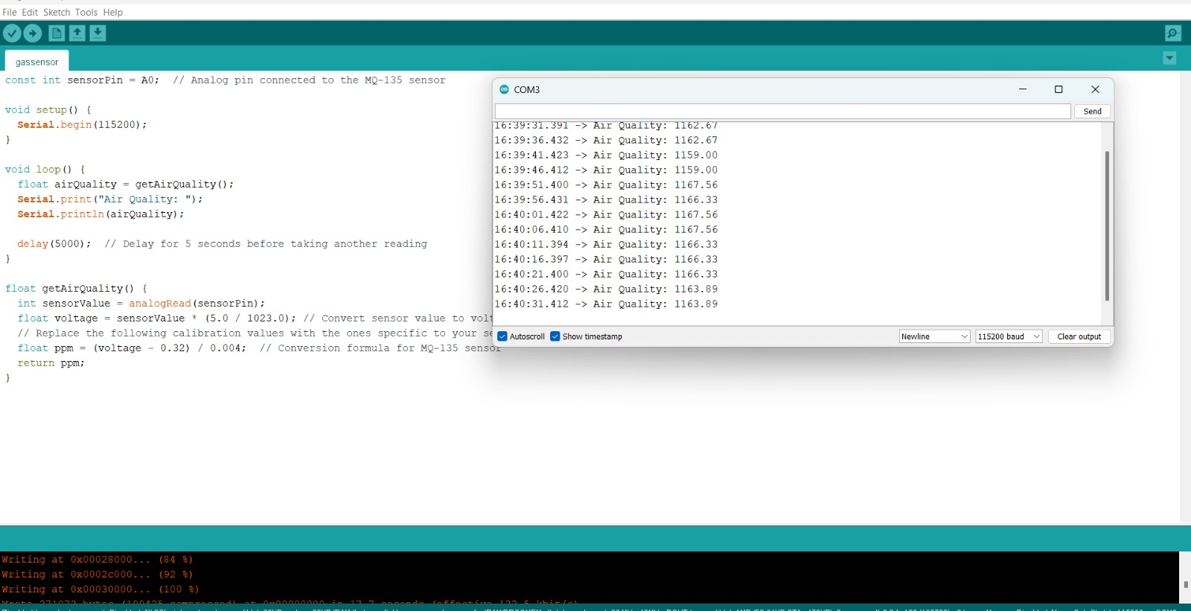

const int sensorPin = A0; // Analog pin connected to the MQ-135 sensor

void setup() {

Serial.begin(115200);

}

void loop() {

float airQuality = getAirQuality();

Serial.print("Air Quality: ");

Serial.println(airQuality);

delay(5000); // Delay for 5 seconds before taking another reading

}

float getAirQuality() {

int sensorValue = analogRead(sensorPin);

float voltage = sensorValue \* (5.0 / 1023.0); // Convert sensor value to voltage

// Replace the following calibration values with the ones specific to your sensor and environment

float ppm = (voltage - 0.32) / 0.004; // Conversion formula for MQ-135 sensor

return ppm;

}

